Project Design Phase-II

Technology Stack (Architecture & Stack)
Date | 02 November 2025
Team ID | NM2025TMID06828
Project Name | Streamlining Ticket Assignment for Efficient Support Operations
Maximum Marks | 4 Marks

Technical Architecture:
The deliverable includes the architectural diagram and the information summarized in the tables below. This architecture represents how the automated ticket assignment system operates within ServiceNow. The system utilizes both AI-based models and rule-based logic to assign tickets to the most suitable support agents based on workload, expertise, and ticket priority.
Example Architecture Diagram:
The Streamlining Ticket Assignment for Efficient Support Operations system automates ticket handling in ServiceNow to improve support efficiency. Users create tickets through a web portal or email, and the system automatically assigns them to suitable agents based on rules like skill, workload, and priority.
The architecture includes three layers:
- The User Interface allows customers, agents, and admins to interact with the system.
- The Application Logic Layer manages ticket creation, validation, assignment, and notifications.
- The Database Layer stores all user, ticket, and assignment data securely in ServiceNow’s cloud.

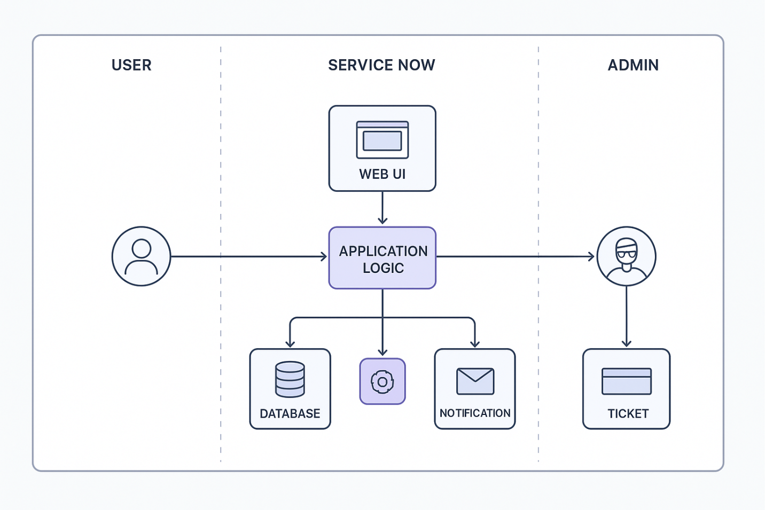Table-1: Components & Technologies
S.No | Component | Description | Technology
1 | User Interface | Dashboard for agents and admins. | ServiceNow Web UI
2 | Logic Layer | Handles ticket categorization and auto-assignment rules. | Flow Designer, Business Rules
3 | Notification System | Sends alerts for new or reassigned tickets. | ServiceNow Notifications
4 | Database | Stores ticket and user data securely. | CMDB / Incident Tables
5 | Cloud Hosting | Ensures scalability and uptime. | ServiceNow Cloud (SaaS)
6 | Integration API | Connects with HRMS or analytics tools. | REST / Power BI API
7 | Automation Engine | Uses AI/ML for predictive ticket routing. | AI Script / ML Integration

Table-2: Application Characteristics
S.No | Characteristic | Description | Technology
1 | Open-Source Frameworks | Not applicable (ServiceNow proprietary). | -
2 | Security Implementations | Role-based access control, secure ACLs, data encryption, and restricted access. | ACLs, Scoped Apps
3 | Scalable Architecture | SaaS-based, horizontally scalable for large ticket volumes. | ServiceNow Cloud Architecture
4 | Availability | High availability ensured through ServiceNow cloud hosting and load balancing. | Load-balanced ServiceNow Instances
5 | Performance | Optimized through asynchronous flows, indexed tables, and efficient background scripts. | GlideRecord, Script Includes

